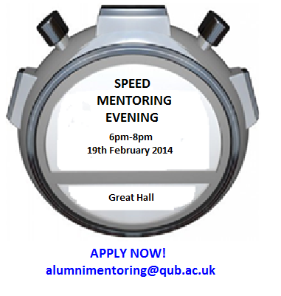

Event Sponsor

Speed Mentoring Evening

Student Application Form – Submit by 18.2.14
Section 1: Personal Details
Name:  Queen’s Student Email Address: | Degree Programme:  Year of Study (L1, L2, L3, PGT etc.):
Section 2: Your Current Career Preferences
Please indicate your preferences for the mentors you would like to speak with during the formal rounds by placing numbers 1 to 5 in the relevant boxes below:

Mentor | Preference No. | Mentor | Preference No.
- Journalist/Television Language Programme Producer (BBC)  (Modern Languages graduate) |  | - Political Policy Adviser  (TBC)
- Marketing & Communications Manager (British Council)  (Modern History & Drama graduate) |  | - Management Consultant (PWC)  (Geography and Environmental Planning Degree/MSc)
- Supply Chain Manager (Bombardier)  (Geography graduate) |  | - Clinical/Educational Psychologist  (Psychology graduate)
- Town/Country Planner  (Geog/Planning & Arch graduate) |  | - Language/Translation Services Manager  (Modern Languages graduate)
- Marketing/Media Manager  (English graduate) |  | - Human Resources Business Mentor/ Adviser: (Social Anthropology graduate with experience of HR in Media, telecommunications, health care and other public sector)
- Self-employed Business Consultant –public, small business and community and voluntary sectors  (History graduate) |  | - A further mentor (banking sector) may be confirmed nearer to the event.

Section 3: Signatures and Agreements
- I understand that this evening does not constitute professional career guidance;
- I understand that all information shared between the mentors and mentees is confidential;
- I agree that my personal information can be shared, as stated in the event Data Promise;
- I confirm that the information I have provided in this form is correct.

E-signature: Date: Student Number:

NOTE: When completed, this form should be emailed, using your Queen’s student e-mail address, to alumnimentoring@qub.ac.uk .

